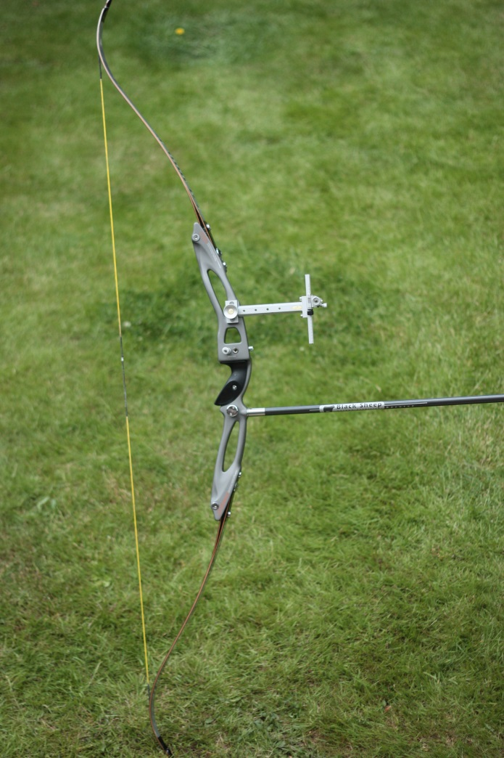
Archery Bow for sale;

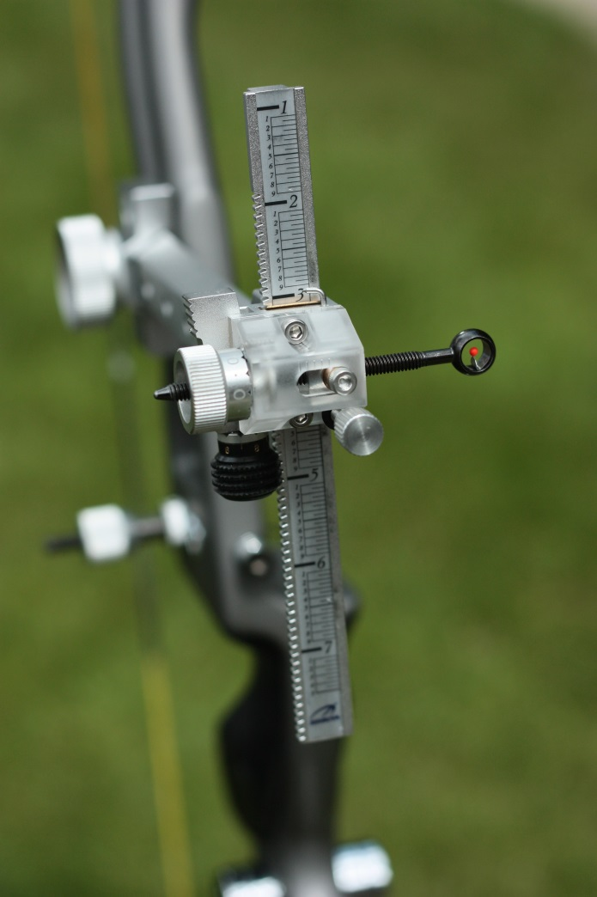
Win & Win Inno CXT, (right hand 25” riser)

MyBow Synergy Carbon limbs ( 32lb @ 68” bow length.)

Shibuya fully adjustable pin sight

Cartel Button, arrow rest (and spare arrow rest)

Blacksheep 30” longrod with doinker fitted.

Cartel Quiver,

Cartel RX10 bow stand,

12x Easton 1916 XX75 30 3/8” arrows complete with carry case.

All complete in a ‘Striker’ Archery bag.

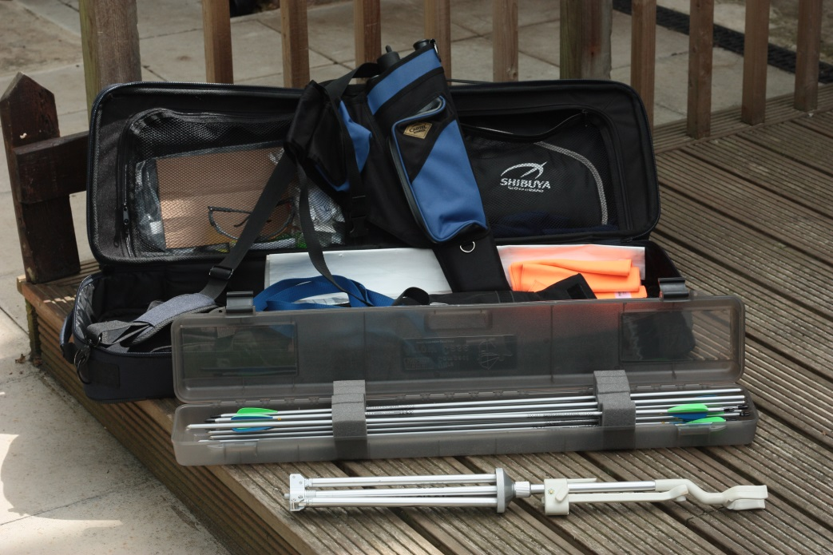
Complete Price: Open to offers,

Please contact :

Antony Cavanagh,

07872 935359

(text first please)

Or

cavan1970@btinternet.com

